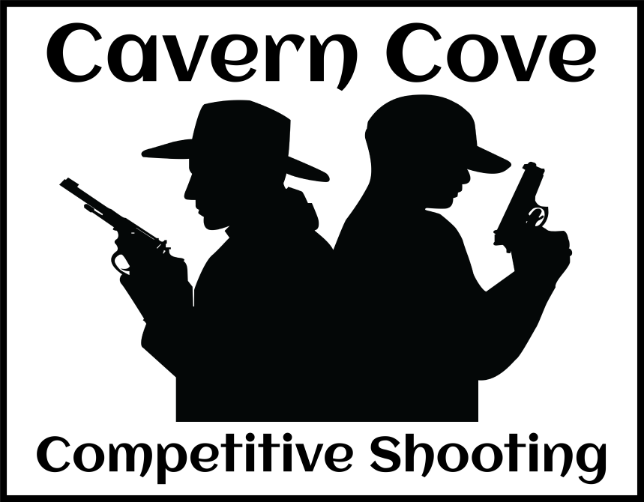

**Agreement of Release**

|  |
| --- |
| Name of Participant or Guardian |
| Address |
| City, State & Zip |
| Phone and email |
| **Name of Minor**/Age /DOB |

I the above named person being eighteen or above, or the legal guardian of the above named person who is under eighteen, inconsideration of the services of Cavern Cove Competitive Shooting LLC the rate charged for those services and the right to engage in activities at Cavern Cove Competitive Shooting LLC range, as a participant or guest of a member herby acknowledge that a temporary membership is granted while attending and participating in a shooting match, practice session and other activities related to the match or session and agree, promise and covenant with Cavern Cove Competitive Shooting LLC and all other persons or entities which maybe connected to Cavern Cove Competitive Shooting LLC as follows.

1. HEREBY RELEASE,WAIVE, DISCHARGE, AND COVENANT NOT TO SUE Cavern Cove Competitive Shooting LLC, their agents, licensed affiliates, employees and assigns, all above named persons and affiliates and any and all other or entities which are related to, arise out of or are in any way connected with participation in the Cavern Cove Competitive Shooting LLC range are for the purposes herein referred to as “Releases” from all liability to the named participant, or the legal guardian of the named participant, his or her personal representatives, heirs, and next of kin for any and all loss or damage, and any claims or demands therefore on account of injury or illness to the person or property or resulting in death of the named participant, whether caused by the negligence of the Releases or otherwise while the participant is participating in any Cavern Cove Competitive Shooting LLC event whether it be active participation or mere observance.

2. The named participant and/or the legal guardian of the named participant expressly acknowledges, understands and appreciates the inherent risks, both known and unknown which maybe involved in the participation in Cavern Cove Competitive Shooting LLC events; including but not limited to Releases sponsored any events occurring at Cavern Cove Competitive Shooting LLC premises, events which by its nature includes intense, stressful and strenuous exercises expressly consents to confront these known and unknown dangers and further agrees, understands and recognizes that these risks may result in serious injury or illness including but limited to; bruises, cuts, broken bones, heart attacks or other cardiovascular diseases, or other serious injury resulting in death and/or property damage. I further understand and acknowledge that these risks may result in personal claims against the Releases, or in claims against me by other participants or other third parties, but I expressly covenant not to use the Releases for any

damages which may result from the named participants participation in any Cavern Cove Competitive Shooting LLC event.

3. The named participant and/or the legal guardian of the named participant hereby assumes full responsibility for and risk of bodily injury, including but limited to; bruises, cuts, broken bones, heart attacks or other cardiovascular diseases, or other serious injury resulting in death and/or property damage due to the negligence of releases or otherwise while participating in any event at Cavern Cove Competitive Shooting LLC range.

4. Each of the named participants or the legal guardian of the named participant expressly acknowledges and agrees that the activities of Cavern Cove Competitive Shooting LLC may be dangerous and involve risk of serious injury or illness and/or death and/or property damage. Each of the named participants and/or legal guardian further expressly agree that the foregoing Release, Waiver, and Indemnity Agreement is intended to as broad and inclusive as permitted by the laws of the state of AL or the law of the province of state in which the event is conducted and that if any portion thereof invalid, it is agreed that the balance shall, not withstanding, continue in full legal force and effect.

5. The named participant and/or the legal guardian of the named participant hereby agrees to, indemnify and save and hold harmless the releases from any loss, liability, damage or cost they may incur due to the named participants participation in Cavern Cove Competitive Shooting LLC events or activities, whether caused by negligence of the Releases or otherwise. I further agree, promise and covenant to hold harmless and indemnify Cavern Cove Competitive Shooting LLC it agents or employees and all other person or entities from all defense costs including Attorney’s fee’s or from any other costs incurred in connection with the claims for bodily injury or property damage which I may negligently or intentionally cause to other third parties in the course of participation in Cavern Cove Competitive Shooting LLC events and activities.

6. The named participant and/or their legal guardian hereby acknowledges receipt of the facility and/or organization rules and agrees to abide by these rules in all activities sponsored by Cavern Cove Competitive Shooting LLC. The named participant and/or their legal guardian hereby affirms that the named participant is in good physical condition and does not suffer from any disability or other condition which would prevent or limit participation in Cavern Cove Competitive Shooting LLC events or activities.

7. The named participant and/or their legal guardian has read and voluntarily signed the release and waiver of liability and indemnity agreement, and further agrees that no oral representations, statements or inducements apart from the foregoing written agreement have been made. By voluntarily affixing my signature below, I warrant that I have read the entire Agreement and understand all of the foregoing: I fully recognize that if anyone is hurt or property is damaged while I am participating in Cavern Cove Competitive Shooting LLC events and activities, I will have no right to make a claim or file a lawsuit against Cavern Cove Competitive Shooting LLC its officers, agents, licensed affiliates or employees even if they or any of them caused the negligently caused the bodily injury or property damage.

______________________________________ ____________________________________ _____________ ___________________________________

Signature of participant Signature of parent/guardian Date Witness